**PROJECT REPORT**

**ON**

**HEALTHCARE KIOSKS**

(INTEL UNNATI)

**Submitted by:**

SHAILJA SINGH

SHIKHAR VERMA

SHIVANSH TIWARI

RITIKA RAWAT



Department of Computer Engineering Applications

GLA University, Mathura

2024-25

**CONTENT**

1. Introduction 04 – 05
2. Current Features and 06 – 18

1. Functions of Healthcare Kiosks
2. Hardware (HW)
3. ISVs
4. System Integrators (SIs)
5. Problem Statements 19

1. Statement 1: 20 – 26

* What is the problem?
* Brief Study of the Topic?
* Solution
* Requirements

1. HW
2. ISVs
3. SIs

* Market Need
* Future Change in Market
* Competitive Analysis
* Graph and Statistics
* Additional Recommendation
* Sources of Content

1. Statement 2: 27 – 34

* What is the problem?
* Brief Study of the Topic?
* Solution
* Requirements

1. HW
2. ISVs
3. SIs

* Market Need
* Future Change in Market
* Competitive Analysis
* Graph and Statistics
* Additional Recommendation
* Sources of Content

1. Statement 3: 35 – 43

* What is the problem?
* Brief Study of the Topic?
* Solution
* Requirements

1. HW
2. ISVs
3. SIs

* Market Need
* Future Change in Market
* Competitive Analysis
* Graph and Statistics
* Additional Recommendation
* Sources of Content

1. Statement 4: 44 – 51

* What is the problem?
* Brief Study of the Topic?
* Solution
* Requirements

1. HW
2. ISVs
3. SIs

* Market Need
* Future Change in Market
* Competitive Analysis
* Graph and Statistics
* Additional Recommendation
* Sources of Content

1. Market Graph 52

**CHAPTER 1:**

**INTRODUCTION**

A Medical Kiosk, also called a Health Kiosk or Health ATM, is a machine that provides basic health checkups and diagnostic services. It is an easy and affordable way to access healthcare, especially in places where doctors or clinics are not available. These kiosks can be placed in offices, schools, and public places, making it simple for people to check their health. They help in providing primary and preventive care without needing full medical staff. Medical kiosks are useful for reaching people in remote or underserved areas, making healthcare more convenient and widely available. [1]

**Parameters and Health Metrics Measured**

Medical kiosks cover a range of [health parameters](https://clinicsoncloud.com/), including:

• Blood Pressure

• Heart Rate

• Body Temperature

• Oxygen Saturation (SpO2)

• Body Mass Index (BMI)

• Blood Glucose Levels

• Haemoglobin and Cholesterol

• ECG (Electrocardiogram)

• Vision and Hearing Tests

• Lung Function (Spirometry), and more

These metrics provide users with a comprehensive health checkup, covering vital signs, chronic disease indicators, and basic physiological functions.

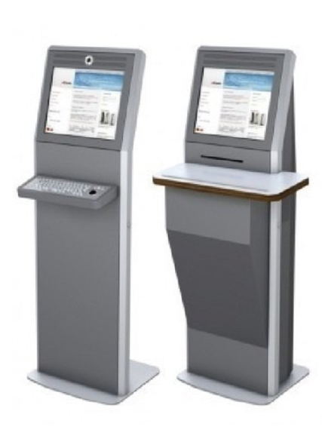

**CHAPTER 2:**

**CURRENT FEATURES AND FUNCTIONS OF HEALTHCARE KIOSKS**

Medical kiosks are smart healthcare machines that bring together various tools for checking and monitoring health in one convenient unit. They are designed to be easy to use, allowing people to perform health checkups with little or no help. These kiosks are especially helpful in places where healthcare access is limited, like rural areas, schools, offices, or public spaces. Below are the main features and functions that make medical kiosks effective and useful.

**1. Vitals Monitoring:**  
One of the main functions of a medical kiosk is to check basic health indicators. These include blood pressure, body temperature, oxygen levels in the blood (SpO₂), heart rate, and Body Mass Index (BMI). The kiosks use built-in sensors to measure these vitals quickly and accurately. These readings help users keep track of their general health and detect early signs of health issues.

**2. Blood Test Analysis:**  
Some advanced medical kiosks can also carry out basic blood tests. They can check blood sugar (glucose) levels, haemoglobin, and cholesterol levels. This is useful for identifying conditions like diabetes, anaemia, or high cholesterol. These tests are done quickly, and results are usually available within minutes. This feature saves time and provides a convenient way to screen for common health problems.

**3. Advanced Diagnostics:**  
More sophisticated medical kiosks go beyond basic tests. They include diagnostic tools like ECG (Electrocardiogram) to check heart activity, spirometry to assess lung function, and even vision and hearing tests. This makes the kiosk suitable for detecting more serious health concerns and helps users understand their overall health better.

**4. Telemedicine and Video Consultation:**  
Many medical kiosks offer the option to speak directly with a doctor or healthcare provider through video consultation. This is known as telemedicine. It is especially useful for people living in remote areas or those who cannot easily visit a clinic or hospital. The user can get medical advice, prescriptions, or follow-up care during the video call, all from the kiosk itself.

**5. Real-Time Reporting and Data Access:**  
After completing the health checkups, the kiosk generates reports instantly. These can be sent to the user’s mobile phone or email, making it easy to store and share health information. Some kiosks also allow users to log in to an online dashboard where they can track their health trends over time. This helps people monitor their progress and maintain better control of their health.

**6. User-Friendly Interface:**  
Medical kiosks are made to be simple and easy to use. They usually have a touchscreen with step-by-step instructions to guide the user through each test. Many kiosks support multiple languages, which helps people from different backgrounds use them comfortably.

In summary, medical kiosks are powerful tools that bring healthcare closer to people by combining various medical services in one easy-to-use machine. Their many features make them useful for regular checkups, early detection of health problems, and direct connection with doctors, all without needing to visit a clinic or hospital.

**Summary at a Glance**

| **Category** | **Highlights** |
| --- | --- |
| **Hardware** | Touchscreens, sensors for vitals, printers, cameras; medical‑grade input & payment modules |
| **ISVs** | American Well, Higi, OnMed, ImageHOLDERS, Versicles |
| **System Integrators** | Olea, KIOSK Info, Meridian, Advantech, Axiomtek, Elo |
| **Features** | Check‑in, vitals, telehealth, payments, wayfinding, AI/motion |
| **Market** | USD 1.4–1.8 b → USD 6–6.2 b by 2030; CAGR ≈13‑15% |
| **Drivers** | Remote care, efficiency, patient self‑service |
| **Challenges** | Cost, privacy, integration, standardization |

**1. Hardware Manufacturers / OEMs**

These companies build **physical kiosk units**—the “Health ATMs” equipped with diagnostic sensors, displays, and connectivity:

* **Clinics on Cloud** (SehatPro India): offers rugged metal‑bodied kiosks with battery backup, CE/FDA/CDSCO/ISO certifications, capable of screening 60+ health parameters in ~15‑minute tests with telemedicine support ([Clinics On Clouds](https://clinicsoncloud.com/health-kiosk/?utm_source=chatgpt.com), [Sehatpro Technologies Private Limited](https://www.healthcarekiosk.co.in/kiosk-system.htm?utm_source=chatgpt.com)).
* **Recorders & Medicare Systems Ltd. (RMS India)**: makers of the Health Kiosk 101, certified (ISO, CE) diagnostic kiosk that measures vitals, BMI, pulse oximetry, dermascope, otoscope, and more ([Medzell](https://www.medzell.net/product/health-kiosk-101-from-recorders-and-medicare/?utm_source=chatgpt.com)).
* **AdvanceTech India**: another key healthcare kiosk manufacturer in India offering customizable units ([atechindia.com](https://atechindia.com/healthcare-kiosk-manufacturers-in-india/?utm_source=chatgpt.com)).

**2. ISVs (Independent Software Vendors)**

These firms provide **software layers** powering the kiosk platform—registry, registration, EHR/EMR, AI diagnostics, UI/UX, analytics:

* **XIPHIAS Technologies**: develops kiosk software for patient registration, appointment scheduling, payment, ID/face recognition, integration with hospital systems, and generates diagnostic & counseling reports ([SourceForge](https://sourceforge.net/software/kiosk/india/?utm_source=chatgpt.com), [XIPHIAS SOFTWARE TECHNOLOGY PVT. LTD.](https://www.xiphiastec.com/health-care-software.html?utm_source=chatgpt.com)).
* **Gateway Digital**: builds med‑tech platforms including EHR/EHR modules, image recognition, analytics dashboards, service kiosk apps, patient self-care, conversational AI, and virtual clinic capabilities ([thegatewaydigital.com](https://www.thegatewaydigital.com/med-tech-healthcare-isvs/?utm_source=chatgpt.com)).

**3. System Integrators (SIs)**

These are IT firms or integrators that stitch together hardware + software + network + compliance to deploy kiosks at scale:

While specific Indian SIs in healthcare kiosks weren’t name‑listed in sources above, typical relevant enterprises include:

* **Large IT integrators** such as TCS, Infosys, Wipro, HCLTech, L&T Technology Services, Tech Mahindra, CMS Computers, Team Computers—known for deploying kiosk solutions and integrating ISV platforms with India Stack, HIS/EMR systems, tele‑medicine networks, and government health initiatives.

**Summary Table**

| **Category** | **Examples & Key Capabilities** |
| --- | --- |
| **Hardware OEMs** | Clinics on Cloud, RMS Health Kiosk 101, AdvanceTech India – medical-grade diagnostic kiosks, battery backup, connectivity, telemedicine hardware ([atechindia.com](https://atechindia.com/healthcare-kiosk-manufacturers-in-india/?utm_source=chatgpt.com), [Clinics On Clouds](https://clinicsoncloud.com/health-kiosk/?utm_source=chatgpt.com)) |
| **ISVs** | XIPHIAS (kiosk software, ID/facial recognition, transaction flows), Gateway Digital (EHR/AI/analytics and virtual clinic platforms) |
| **System Integrators** | Tier‑1 Indian IT services firms that integrate hardware and ISV software into full deployments, manage installation, compliance, link to India Stack/ABDM/telemedicine infrastructure |

**How They Work Together:**

* **OEMs** supply certified, turnkey kiosk hardware loaded with diagnostic sensors, touchscreen, camera, printer, and connectivity.
* **ISVs** provide the software stack—user interface, patient registration, ID verification (face/Aadhaar), integration with EHR/HIS, teleconsultation UI, AI‑based report generation.
* **SIs** customize workflows, integrate with hospital IT systems or ABDM / India Stack APIs, manage roll‑out logistics, certifications, training, and support.

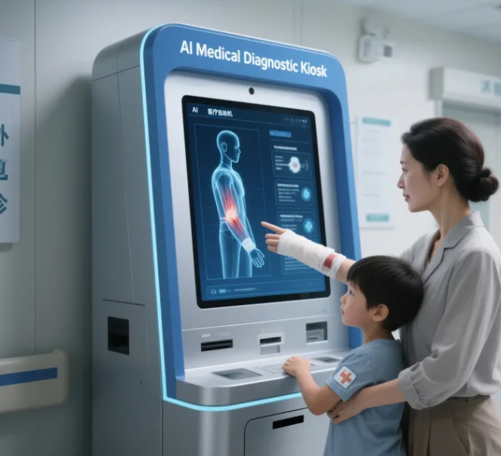

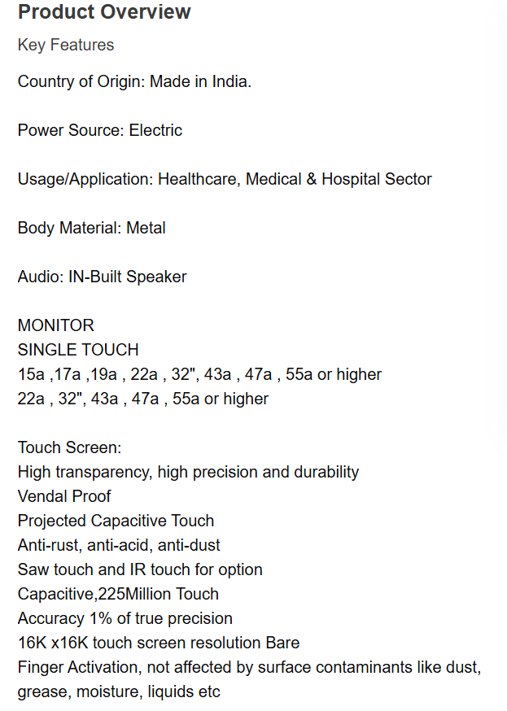

**NOTE => From appointment scheduling to report printing, self-service terminals accompany the whole process.**

STEP 1:

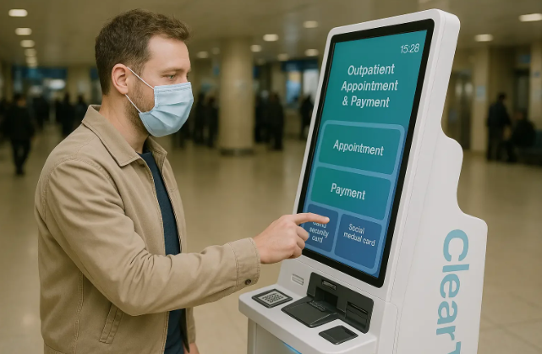

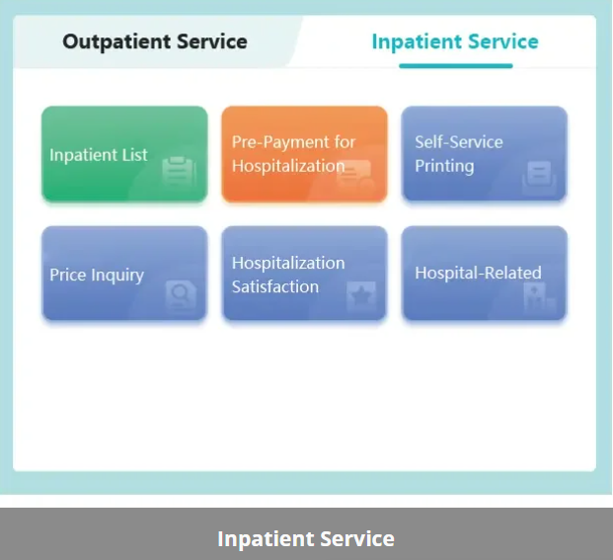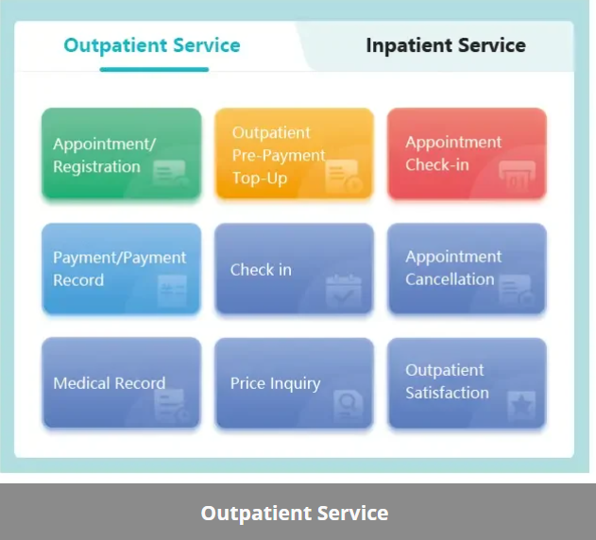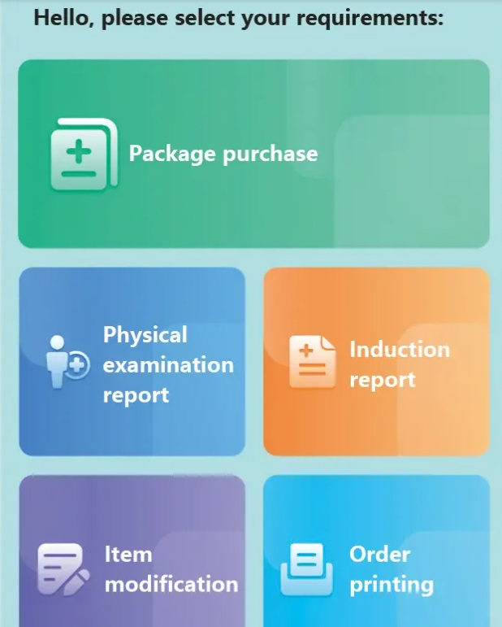

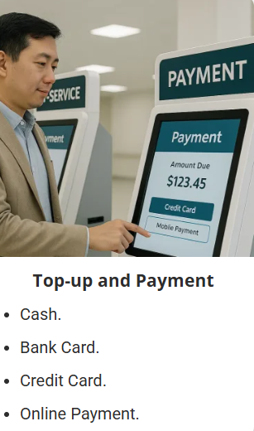**STEP 2: STEP 3:**

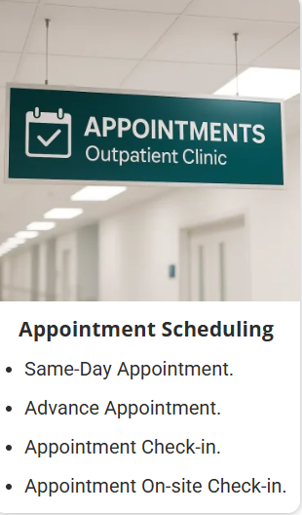

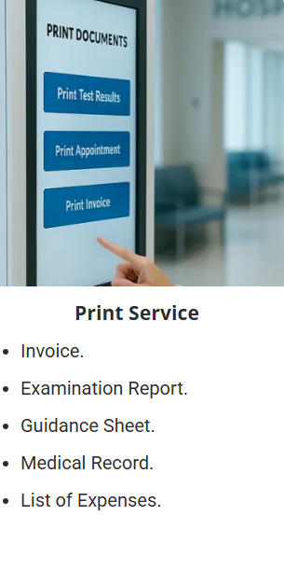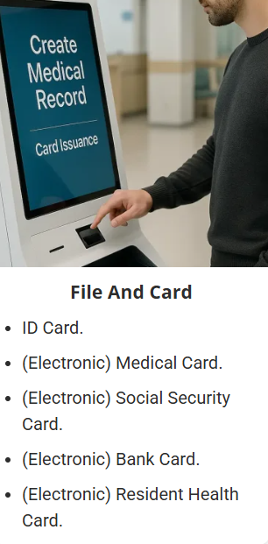**STEP 4: STEP 5:**

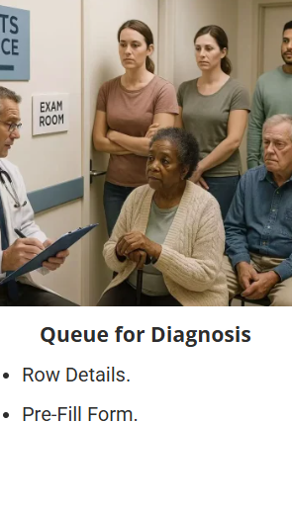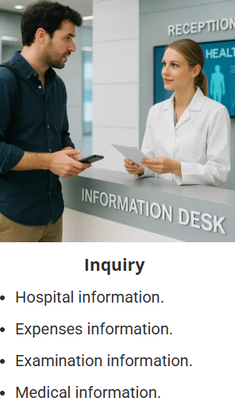**STEP 6: STEP 7:**

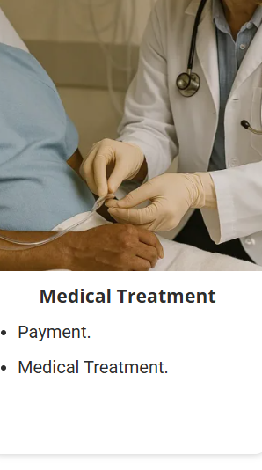**STEP 8: STEP 9:**

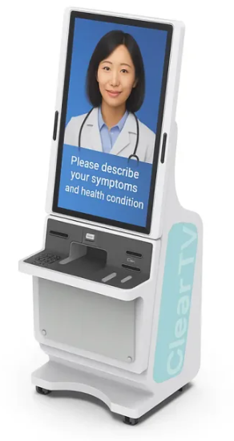

**Scene fusion**

With one-stop self-service as the core, to create a smart hospital scene integration system.

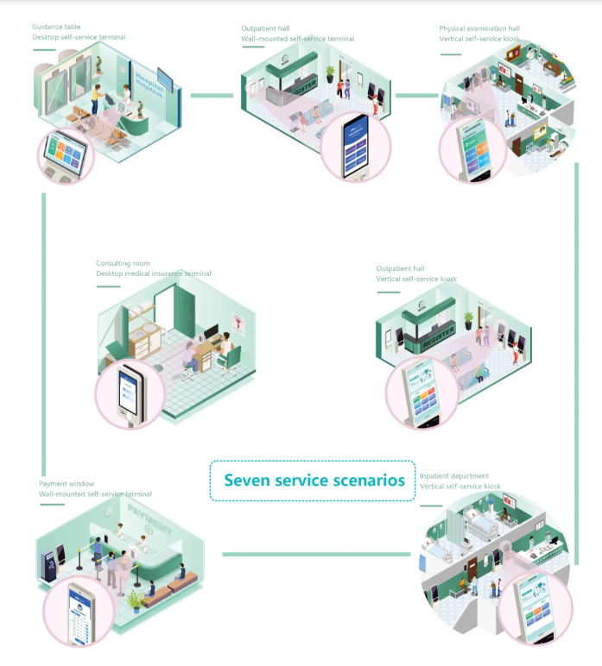

Kindly zoom the images to get a better understanding

https://www.cleartv.net.cn/page/medical-self-service-terminal?gad_source=1&gad_campaignid=22739327250&gbraid=0AAAAAo5pzwFn02Zes33jOsET8s10KeWKv&gclid=Cj0KCQjwj8jDBhD1ARIsACRV2Tur1VQJJHikNUE7s6X8-Zz9FNvXDDgZGQIJElYwMBaaiOE4iylVPKMaAhTwEALw_wcB

**CHAPTER 3:**

**PROBLEM STATEMENTS:**

**Healthcare Kiosks**  
**Should Intel co-create a new Device Category or add features to existing Healthcare Kiosk?**

1. Can the Healthcare Kiosk be linked to the India Stack (India’s Digital Public Infrastructure platform)?
2. Can technologies like face ID recognition be brought in with advanced authorization from the patient, as seen in Digi Yatri Kiosks, to fasten the registration and check-in process?
3. Can the Healthcare Kiosk serve as a system that immediately monitors patient’s vitals, sends a report along with medical history data with any relevant lab or imaging results?
4. Can the Healthcare Kiosk conduct medical transcribing for the case being discussed by using AI and LLMs (large language models) that too for Indians in various Indian Languages and Dialects?

**CHAPTER 4:**

**STATEMENT 1**

**What is the Problem?**

India’s healthcare system faces challenges like:

* Long wait times
* Staff shortages
* Fragmented health records
* Manual paperwork
* Limited digital access in rural areas

**Healthcare kiosks** can help solve these problems but lack integration with **India Stack**, which includes tools like Aadhaar, DigiLocker, ABHA (Ayushman Bharat Health Account), and eKYC.

**Brief Study of the Topic:**

India Stack is a set of APIs and digital infrastructure including:

* **Aadhaar** (identity)
* **DigiLocker** (document storage)
* **eSign**, **UPI**, and **ABDM/ABHA**

Healthcare kiosks are physical touchpoints where patients can:

* Register themselves
* Upload or download health records
* Book appointments
* Teleconsult with doctors  
  But without India Stack integration, these kiosks operate in silos.

**Solution:**

**Integrate Healthcare Kiosks with India Stack APIs** to:

* Auto-fetch health documents from DigiLocker
* Authenticate identity via Aadhaar + OTP
* Access and update ABHA-linked health records
* Enable digital consent for data sharing
* Link with insurance, hospitals, and pharmacies in real-time

**Requirements:**

1. **HW (Hardware)**

* Touchscreen Kiosk Terminal
* Camera (for Face ID)
* Aadhaar biometric reader or QR scanner
* Thermal printer
* Intel-based processor with TPM module
* Vitals devices: BP monitor, oximeter, thermometer, ECG

1. **ISVs (Independent Software Vendors)**

* **XIPHIAS** – kiosk interface software
* **Gateway Digital** – ABHA/EHR sync software
* **Vernacular.ai**, **Reverie** – for multilingual support
* **Qure.ai**, **DeepTek** – AI-based diagnosis tools

1. **SIs (System Integrators)**

* **TCS, Wipro, Infosys, L&T, CMS Computers**
* Provide backend integration, hardware + software deployment
* Connect to ABDM, hospital networks, and cloud storage

**Market Need:**

* Government push for **Ayushman Bharat Digital Mission (ABDM)**
* Patients demand fast, paperless healthcare
* Rural India lacks full-time doctors—kiosks can bridge the gap
* Insurance claim systems need digitization at entry points
* COVID-19 accelerated adoption of touchless systems

**Future Change in Market:**

* **Healthcare kiosks** to evolve from self-check-in tools into **smart health hubs**
* Face ID, AI triage, e-prescriptions, and diagnostics will become common
* Integration with **NDHM**, **ABHA**, **eSanjeevani**, and **UPI**
* Private clinics and pharmacies will adopt kiosks at a faster pace

## **Competitive Analysis:**

| **Feature** | **Without India Stack** | **With India Stack** |
| --- | --- | --- |
| Identity Verification | Manual, slow | Aadhaar + OTP/Face ID (fast) |
| Medical Record Access | Local only | ABHA-linked, national portability |
| Data Sharing | Paper-based, fragmented | Consent-based digital transfer |
| Insurance Claims | Offline, time-consuming | Instant e-KYC + policy validation |
| Rural Access | Low | Remote access via DigiLocker |
| Teleconsult Integration | Limited | Full sync with eSanjeevani |

**Graph & Statistics**

* **Healthcare Kiosk Market Size**
* 2023: **USD 1.4–1.6 Billion**
* 2030 (Projected): **USD 3.8 Billion**
* 2033 (Projected): **USD 5.36 Billion**
* CAGR: **15%**
* **Self-Service Kiosk Industry**
* 2023: **USD 23.9 Billion**
* 2033 (Projected): **USD 48.3 Billion**
* CAGR: **7.3%**
* Healthcare is the **fastest-growing** segment post-COVID
* **India-Specific Drivers:**
* 1.4 billion Aadhaar users
* 300+ million ABHA accounts (target: 1 billion+)
* Rapid government investment in digital public infrastructure (DPI)

**Additional Recommendations:**

* **Governance Framework**
* Consent-based data access (DPDPA compliance)
* Face ID systems must be opt-in
* Role-based access for hospitals, doctors, insurers
* Audit logs and transparency dashboards for patients
* **Interoperability Protocols**
* Use **FHIR/HL7** to standardize EHR access
* Sync with DigiLocker, e-Sanjeevani, ABHA, HealthID
* Cross-hospital data sharing via secure APIs

**Source of Content:**

* [India Stack Overview](https://www.indiastack.org)
* [ABDM](https://abdm.gov.in)
* Digital Personal Data Protection Act, 2023
* [Digi Yatra facial recognition](https://en.wikipedia.org/wiki/Digi_Yatra)
* PDF source: *Healthcare Kiosk Integration with India Stack* (uploaded by user)

**CHAPTER 5:**

**STATEMENT 2**

**What is the Problem?**

Hospitals and clinics face long patient queues, manual check-ins, identity fraud, and inconsistent access to medical records—especially in high-traffic or underserved areas.

**Brief Study of the Topic**

Healthcare kiosks have emerged as digital check-in terminals for basic tasks like appointment scheduling and payment. A proposed evolution is to integrate **Face ID recognition**, inspired by India's **Digi Yatra** system at airports, to enable **fast, contactless, and secure patient registration**. However, this brings challenges around data privacy, cost, consent, and technical infrastructure.

**Solution:**

Use **facial recognition with patient consent** at healthcare kiosks to:

* Speed up registration (<10 seconds)
* Retrieve Electronic Health Records (EHRs)
* Improve hygiene via contactless check-ins
* Enable teleconsultation in remote areas
* Support national health initiatives like **ABDM** and **ABHA ID**

**Requirements:**

**1. HW (Hardware)**

* Intel Core™ or Atom® processors (11th–14th Gen)
* RealSense cameras for Face ID
* Edge AI chips (Intel Movidius VPU)
* Trusted Platform Modules (TPM) for encryption
* Touchscreen, biometric scanners, printer, UPS
* Medical devices (BP monitor, thermometer, ECG, oximeter)

**2. ISVs (Independent Software Vendors)**

* **XIPHIAS** – healthcare kiosk software
* **Gateway Digital** – EHR, AI integration
* AI tools: **OpenVINO**, **Qure.ai**, **Sigtuple**, **DeepTek**
* Language/NLP: **Reverie**, **Google Dialogflow**

**3. SIs (System Integrators)**

* **TCS**, **Infosys**, **Wipro**, **Tech Mahindra**, **L&T**, **CMS Computers**
* Integrate kiosks with hospital IT systems, ABDM, DigiLocker, and insurance platforms

**Market Need:**

* Rising pressure on hospitals post-COVID
* Need for **contactless**, **hygienic**, **automated** check-ins
* Staff shortages → automation needed
* Rural healthcare requires scalable access points
* Increasing demand for AI diagnostics and teleconsultation.

**Future Change in Market:**

* Shift from basic kiosks to **AI-powered health hubs**
* EHR integration and real-time cloud sync will become standard
* Face ID to be mainstream as DPDPA (India’s privacy law) matures
* Global healthcare kiosk market projected to **reach USD 5.36B by 2033**
* Rise of modular, interoperable kiosk ecosystems like **Intel HealthStack**

### **Competitive Analysis:**

Intel is advised to follow a **hybrid approach**:

* **Phase 1 (2025–26)**: Enhance existing kiosks with modular kits (Face ID + AI)
* **Phase 2 (2026–28)**: Launch Intel-designed flagship kiosk
* **Phase 3 (2028+)**: Build an open ecosystem (Intel HealthStack for kiosks)

| **Feature** | **Build New Device** | **Enhance Existing Kiosks** |
| --- | --- | --- |
| Time to Market | 12–24 months | 3–6 months |
| Cost | High | Medium |
| Innovation Flexibility | Very High | Moderate |
| Ecosystem Disruption | Yes | Minimal |
| Market Penetration Speed | Slower at first | Fast |
| Compatibility with EHR/ABHA | Built-in | Needs retrofitting |
| Sustainability (ESG) | Moderate | High (reuse hardware) |

**Graphs & Statistics:**

* **Global Healthcare Kiosk Market**
* 2023: **$1.4B–$1.6B**
* 2030 (Projected): **$3.8B**
* 2033 (Projected): **$5.36B**
* CAGR: ~**15%**
* **Self-Service Kiosk Market (All Industries)**
* 2023: **$23.9B**
* 2033 (Projected): **$48.3B**
* CAGR: **7.3%**
* Healthcare is one of the fastest-growing segments post-COVID
* **Regional Highlights**
* **North America**: Highest adoption (hospitals, clinics)
* **Asia-Pacific**: Fastest growth (India's ABDM driving adoption)

**Additional Recommendations :**

* **Governance & Policy**
* Create a **central regulatory body** (like UIDAI for Aadhaar)
* Standardize Face ID use in hospitals
* Ensure fallback options for non-digital populations
* Align with India’s **DPDPA 2023** for privacy protection
* **Ecosystem Design**
* Modular SDK/API kits for easy adoption
* ABHA/DigiLocker/insurance integration
* Public dashboards, patient opt-in logs
* Vendor certification program for kiosk providers

**Sources of Content:**

* Wikipedia citations :
  + [Digi Yatra](https://en.wikipedia.org/wiki/Digi_Yatra)
  + [Ministry of Civil Aviation](https://en.wikipedia.org/wiki/Ministry_of_Civil_Aviation_(India))
  + [Atal Innovation Mission](https://en.wikipedia.org/wiki/Atal_Innovation_Mission)
  + [DPDPA Act](https://en.wikipedia.org/wiki/Digital_Personal_Data_Protection_Act)
* Intel AI & Edge Technology platforms: intel.com/openvino
* Healthcare Kiosk Market Reports

**CHAPTER 6:**

**STATEMENT 3**

**What is the Problem?**

Hospitals are overwhelmed by long queues and manual record-keeping. Doctors lack instant access to a patient’s vitals, past history, and lab/imaging results during consultations. There is a need for an automated system that can handle these tasks quickly, especially in rural or high-traffic areas.

**Brief Study of the Topic**

Healthcare kiosks started as basic check-in and registration stations. Over time, they evolved to include vitals monitoring and teleconsultation. But they still don't provide:

* Real-time integration with hospital records (EHR/EMR)
* Uploads of lab results or medical imaging
* Automated diagnostic suggestions

This gap can delay diagnosis and overload healthcare staff, especially in places with limited doctors.

**Solution:**

Develop **smart healthcare kiosks** with:

* **Real-time vitals monitoring** (BP, ECG, glucose, etc.)
* **Automatic access to patient history** from hospital databases
* **Integration with lab/imaging systems** (e.g., PACS, LIMS)
* **AI-based diagnostic suggestions** for faster decisions
* **Auto-generated reports** sent to doctors or stored in the cloud

**Requirements:**

* **HW (Hardware)**
* Biometric or NFC/RFID readers (for patient ID)
* GPU-enabled kiosk systems (for DICOM image viewing)
* Thermal printers for on-site report printing
* Medical-grade sensors: BP, ECG, glucose, SpO2
* Modular components for upgrades
* **ISVs (Independent Software Vendors)**
* **OnMed** – Teleconsultation and diagnostics
* **Higi** – Vitals and wellness monitoring
* **HealthSpot** (retired) – Past leader in telehealth kiosks

*Functions provided:*

* UI and vitals interface
* EMR/EHR integrations (using HL7/FHIR)
* AI-driven triage and report generation
* **SIs (System Integrators)**
* **Wipro**, **Tech Mahindra**, **Infosys**, **CSC**
* Deploy kiosks, integrate them with hospital systems
* Offer backend support, maintenance, and training

**Market Need:**

* Urban hospitals face long wait times in OPDs
* Rural regions lack specialists and lab facilities
* There's growing pressure to adopt **decentralized** healthcare
* The need for **automated, real-time patient assessment** is rising
* Increasing health awareness and demand for **convenient care**

**Future Change in Market:**

* **Legacy kiosks** will be replaced or upgraded to AI-enabled diagnostic systems
* Kiosks will connect with EHRs, cloud systems, and national health databases
* Demand will increase in **schools**, **airports**, **offices**, and **rural clinics**
* Modular kiosks may be offered on **subscription** or **SaaS** basis
* Integration with **wearables**, **mobile apps**, and **teleconsultation platforms**

**Competitive Analysis:**

| **Company** | **Strengths** | **Weaknesses** |
| --- | --- | --- |
| **Higi** | Strong in vitals + health education | Lacks AI diagnostics |
| **OnMed** | Video consultation + diagnostics | Limited availability |
| **New AI Kiosks** | Real-time data + lab integration | Requires more R&D & training |
| **HealthSpot** | Early leader, now retired | Discontinued |

**Intel-enabled kiosks** can offer:

* AI + Cloud + Hardware acceleration
* Modular setup
* Real-time report delivery
* Better integration with hospital and national systems

**Graphs and Statistics:**

* **Healthcare Kiosk Market Size**
* **2023**: USD **1.3–1.42 billion**
* **2030 forecast**: USD **3.1–3.8 billion**
* **CAGR**: ~**11–15%**
* **Market Regions**
* **North America**: 35–47% market share
* **Asia-Pacific (APAC)**: Fastest-growing due to rural demand
* **Use Cases Expanding To:**
* **Airports**: e.g., Bradley Airport, USA
* **Schools**
* **Corporate wellness zones**
* **Remote villages** (e.g., OnMed deployment in Bruni, Texas)

**Additional Recommendations :**

### Product Lifecycle Mapping

| **Stage** | **Current Feature** | **Enhanced Feature** | **Needs** |
| --- | --- | --- | --- |
| Development | UI + vitals prototype | EHR + AI + imaging integration | GPU, cloud, APIs |
| Introduction | Rural clinic pilots | Report automation | Support, training |
| Growth | Vitals + teleconsult | AI predictions, multilingual | Regional SI partners |
| Maturity | Fixed feature kiosks | Global rollout, remote updates | Certification, scaling |
| Decline | Legacy units | SaaS, mobile-linked systems | Trade-ins, upgrades |

* **Real-World Examples**
* **OnMed Kiosk in Bruni, Texas** – Free access to diagnostic care in remote areas
* **Bradley Airport, Connecticut** – First airport-based kiosk offering instant vitals + virtual consult

**Sources:**

* [OnMed Experience](https://www.onmed.com/carestation-experience)
* CT Insider Report
* LMT News on Telehealth in Texas
* [Market Data](https://www.gminsights.com/industry-analysis/medical-kiosk-market)
* [Mordor Intelligence](https://www.mordorintelligence.com/industry-reports/medical-kiosk-market)

**CHAPTER 7:**

**STATEMENT 4**

**What is the Problem?**

Doctors spend a lot of time writing or typing case notes during patient consultations. This delays care, creates backlogs, and increases administrative stress. In places with high patient loads or in rural setups with limited doctors, this leads to poor-quality record-keeping and short consultations.

**Brief Study of the Topic**

**Medical transcription** is the process of converting doctor-patient conversations into written records. Traditionally done manually, it's now moving towards **AI-powered voice-to-text transcription** using **Large Language Models (LLMs)** and **Natural Language Processing (NLP)**.

By embedding this capability into **healthcare kiosks**, we can automate case documentation—especially in multilingual environments like India—making healthcare faster, more accurate, and accessible.

**Solution:**

Equip healthcare kiosks with:

* **AI-powered voice transcription** systems
* Real-time documentation of **patient-doctor conversations**
* Multi-language support (Hindi, Tamil, Bengali, etc.)
* Automatic **summarization** of case history, vitals, diagnosis, and prescription
* Sync with EHRs so doctors don’t have to type anything.

**Requirements:**

* **HW (Hardware)**
* High-quality microphones and speakers (for voice capture and playback)
* GPU/AI accelerator (to run LLM inference on edge)
* Camera (optional – for identity verification)
* Secure storage (TPM-enabled devices for data protection)
* Touchscreen interface for review/edit/approve
* **ISVs (Independent Software Vendors)**
* **AI/NLP Providers**:
  + **OpenAI GPT**, **Google Dialogflow**, **Microsoft Azure Health Bot**
* **Speech-to-text Engines**:
  + Google Speech API, Whisper by OpenAI, Vernacular.ai, Microsoft Azure STT
* **Language Translators**:
  + Reverie Language Technologies (for Indian languages)
* **SIs (System Integrators)**
* **Wipro**, **Infosys**, **Tech Mahindra**, **L&T**
* Responsibilities:
  + Integrate AI modules into kiosk systems
  + Connect with EHRs and hospital data flow
  + Manage localization and compliance with privacy laws

**Market Need:**

* Doctors spend **35–50%** of their time on paperwork
* In India, patient consultations average **2–5 minutes**
* There’s a shortage of trained staff in rural areas
* Need to document conversations in **local languages**
* Rise of **telemedicine** and **automated case processing** post-COVID

**Future Change in Market:**

* Voice-based EHR input will become mainstream in OPDs
* LLMs will support **contextual diagnosis suggestions**
* Regional language models will bridge the rural-urban care divide
* AI transcription tools will power **smart health assistants** within kiosks
* Integration with India Stack (ABHA, DigiLocker) will make records portable and secure

## **Competitive Analysis:**

**Key competitors** using AI voice tech:

* **Nuance (Microsoft)** – AI dictation for hospitals (dominates in the US)
* **Suki.ai** – Voice-based medical notes (emerging in India)
* **Google Health** – Doctor-assist tools via AI voice
* No kiosk-focused LLM solutions in India yet → **first-mover advantage possible**

| **Feature** | **Manual Transcription** | **AI-Powered Kiosk Transcription** |
| --- | --- | --- |
| Speed | Slow (done after consult) | Real-time |
| Language Support | Limited | Multilingual (regional) |
| Cost | High (human transcription) | Low (scalable AI models) |
| Integration with EHRs | Manual entry | Auto-sync |
| Scalability | Not feasible in rural areas | Easily deployable via kiosks |
|  |  |  |

**Graphs and Statistics:**

**Global medical transcription market size**: USD **1.67 billion** in 2022

* + Projected to reach **USD 4.7 billion** by 2030 (CAGR: ~14%)
* **Time savings**: AI transcription can save **20–30%** of a doctor's time
* **Multilingual market potential**: Over **70% of India’s population** speaks regional languages → need vernacular AI tools

**Additional Recommendations :**

* **Privacy & Legal Compliance**
* Must comply with:
  + India’s **DPDPA 2023**
  + **HIPAA** (for global use)
* Include **opt-in consent models**
* All audio/text data must be encrypted (at rest & in transit)
* **Ecosystem Integration**
* Link with:
  + **ABHA ID**
  + **DigiLocker for prescription storage**
  + Hospital PACS for lab/imaging cross-reference
* Option for **doctor verification/edit** before final record generation

**Sources of Content**

* Extracted from uploaded PDF: *Healthcare Kiosk AI Medical Transcription Report*
* Industry stats from:
  + [Mordor Intelligence](https://www.mordorintelligence.com)
  + [Market Research Future](https://www.marketresearchfuture.com)
  + [OpenAI Whisper](https://github.com/openai/whisper)
  + [Suki.ai](https://www.suki.ai/)
  + [Reverie Language Tech](https://www.reverieinc.com/)

**CHAPTER 9:**

**MARKET GRAPH**

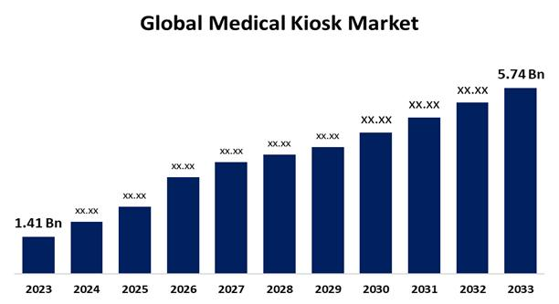  
**Self-Service Kiosks Growth – Broader**

